















Shorncliffe Nursery
All about Us!

Welcome to Shorncliffe Nursery we would like to give you some information all about us, as your child starts their journey within the nursery. At Shorncliffe Nursery we will work in partnership with every family to provide the highest quality childcare in a safe, stimulating, and nurturing environment.
The nursery has two playrooms. The caterpillar room is for children from 2- 3 years; we have a group up to 12 children in this playroom, with access to the garden. The Butterfly Room is for children from 3 years until they go to school. This room has up to 24 children per session and also has access to straight out to the garden.
The nursery has a designated quiet room; this room is a multi-functional room, offering a confidential space for parents/ carers to feel comfortable to talk openly in. We also offer parents meetings, coffee mornings and outside agencies meetings here.
The nursery has two gardens, a smaller garden to the front of the building where the nursery promotes outdoor play and learning during all weathers. The big nursery garden is at the rear of the building, with large physical climbing and balancing equipment. A large sand and water table, also seasonal vegetable growing. Children can access the outdoor forest school activities, learning through new and exciting challenges.

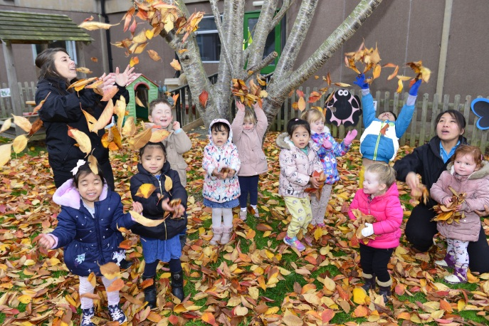

Meet the Nursery Team
 |  | 
 | Annika  Nursey Manager | Lisa  Deputy Manager  & SENDCo
The Caterpillar Room
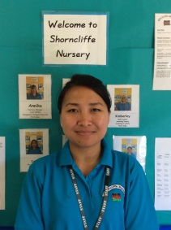 |  | 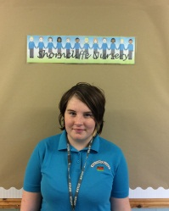 | 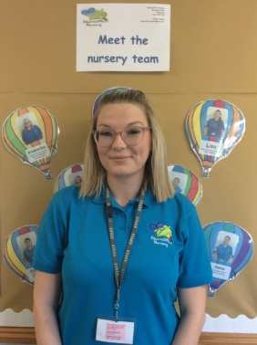
Kalpana  Caterpillar Room  Level 3 Educator | Annie  Caterpillar Room  Level 3 Educator | Brittany  Caterpillar Room  Level 3 Educator | Becky  Caterpillar and Butterfly Room  Cover Practitioner
The Butterfly Room
 | 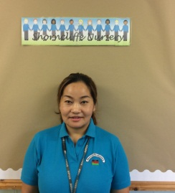 |  | 
Kimberley  Butterfly Room  Level 3 Educator | Ishu  Butterfly Room  Level 3 Educator | Jasmine  Butterfly Room  Level 3 Educator | Aimee  Butterfly Room  Working towards Level 3 Educator

Your child’s Key worker is ………………………………………….
Your child’s key person will work hard to build a relationship with your child and ensure your child become familiar with the nursery and feels safe and secure. They will ensure that every child’s care is tailored to meet their individual needs.
They Parent Partnership
At Shorncliffe we recognise the importance to make parents feel as comfortable as possible with the childcare they choose. We operate an open door policy and are happy for parents or potential parents to visit us when they wish too. We see the importance to discuss every aspect of their child’s care on a regular daily basis either with a member of staff or the manager.
We hold termly parents afternoons, where you are invited to come and talk to your child’s key person and look through their special “learning journeys” which your child’s key person updates weekly. This is a lovely time to share stories, engage in your child’s development. The nursery also offers events such as termly stay and play sessions, sports day, graduation, end of term parities and Christmas parties. The nursery has an active internet safety policy and we encourage parents and the local community to work together to safeguard our children and families when using the internet.
Activities on Offer
The nursery enjoys being outside and we are very lucky to have two outdoor spaces that we use daily, the nursery staff promote the children to be able to undertake activities of their interest. These activities are fun and exciting and engage the children in lots of new skills and building on what the children already know. The nursery believes in taking safe risks, and showing children how they can keep safe, for example crossing the road, stranger danger and activities such as hammer and nails sewing and cutting up our fruit at snack time and making things ourselves. All these activities have lower staff ratio and more supervision. All are risk assessed, and kept safely out of the way. We use this as a learning tool to show how important safety is.
Sand Play
Play dough Table
Paint station
Investigation
Risk Taking
Cooking
Art and Craft
Messy play
Group Games
Experiments
Physical play

Painting
Drawing
Reading stories
Rhymes and Songs
Dancing and music and movement
Outside Nature Play
Water Play
Role Play
Building

Daily Activities

Special Educational Needs
The nursery Special educational needs coordinator is Lisa (SENCo) Lisa works very closely with families and your child’s key worker and offers support when needed. Lisa ensures that the nursery delivers quality care that is needed in conjunction with outside agencies. The nursery works closely with parents to provide detailed individual plans for your family and child to help your child reach their full potential and next steps.
The nursery can offer one to one support for children, when needed who have been accepted through outside agencies as requiring this level of support. All children regardless of their needs are treated equally within the setting; activities on offer will be adapted to maintain independence and equality. Lisa runs a drop in session each term, inviting any nursery parents to attend who have any worries or concerns regarding their child’s development.

Learning at Home
The nursery has a toy library, situated in our quiet room, as well as a lending library at the nursery front door. These both have different resources available for you to borrow, being able to spent time together and explore new resources and materials at home. These are available to all families and hope that they are able to start some fun and exciting thinking and projects at home.
The nursery mascot is “George the bear” he visits family homes with his special book. Each child gets a chance to take him home and have an adventure, whatever the weather. We ask parents to write down what they have done, draw a picture or stick in photos. We use this as a language tool and start some great conversations with it. Also we can plan more in-depth for each child.
The nursery would like you to share in the children’s learning at home, staff will provide you with what your child has been enjoying and learning during their sessions, please do send us photos of this at home too, we would love to look and talk to your child about it in the nursery.
Our Routine
Each nursery room has their own routine, which is flexible as the children enjoy their chosen activities, it can be extended and no child has to rush to get onto the next thing.
Our basic routine is
Caterpillar Room |  | Butterfly Room
Morning session |  | Morning session
9:00 | Welcome free play | 9:00 | Welcome free play
9:15 | Adult lead activity begins & free play  Outside activities & free play | 9:30 | Adult lead activity begins & free play  Outside activities & free play
10:15 | Snack bar starts. Toys changed and refreshed | 10:20 | Snack bar starts. Toys changed and refreshed
11:00 | Group activity begins./ free play continues | 11:00 | Small groups- letters and sounds- key person time- free play if the children prefer
11:50 | Tidy up time and washing hands | 11:50 | Quiet time in the book corner if they would like to join in
12:00 | Home Time | 12:00 | Home Time
Afternoon Session |  | Afternoon Session
12.10 | Lunch Time | 12.10 | Lunch Time & quiet activities on offer
12:30 | Free play - Outside activities & free play | 12:50 | Circle time if they would like to join in
1:15 | Adult lead activities to run alongside free play | 1:15 | Group activity begins  Change of activities if required , Outside activities & free play
2:15 | Drink Time | 2:00 | Small groups- letters and sounds- key person time- free play if the children prefer
2:25 | Free play - Outside activities & free play
2:50 | Tidy up & helping hands time Quiet time in the book corner- what a star | 2:50 | Quiet time in the book corner
3:00 | Home time | 3:00 | Home time

At snack time the children enjoy a variety of foods each day, each snack is a fresh fruit snack. The children self-pouring their own milk or water. Each day children can choose a snack to go with their fruit. We encourage the children to cut up their own snacks and be independent with a practitioner on hand at all times. An example of some of our snacks-

Rice Cakes
Fruit
Cheese
Crackers and spreads
Cereal
Sandwiches
Soap
Yoghurts

Toast
Bread sticks
Crumpets
Pancakes
Cheese twists
Brioche and pastries
Vegetable sticks
Dips

Snack Time

Policies and Procedures.
The nursery has a policy folder which is situated in the main nursery hallway next to the front door; this is always available for you to read. Alternatively all polices can be emailed to you on request.
These polices Include – Safeguarding – E-Safety-Behaviour-Complaints-EYFS-Equality and many more

